Advanced Laboratory in Neural Science
NSC/PSY 4130-01 Syllabus
Fall 2025 In-Person
Mondays 2:30-4:30

Instructor: Joaquin N. Lugo, Ph.D.
Lab: BSB C.405

Teaching Assistants: Victor Julián Padilla, Sc.M.
Office Hours: by appointment

E-Mail: victor_padilla2@baylor.edu (Monday 2:30-4:30)
mariana_dejeux1@baylor.edu (Tuesday 3:30-5:30)

Welcome to class! I look forward to a great semester with you. This course is designed to give you a better understanding of the methods and procedures in Behavioral Neuroscience through lectures, experiments, and some assignments.

Canvas
Most of the course materials will be available on Canvas. Material will be listed by the class date and topic. Material may not appear in the order it was presented. It is your responsibility to ensure you are reviewing/studying the correct material.

Contacting Me
One of the best ways to take full advantage of learning in this lab is by coming to my office hours (scheduling a time to meet). You can also email me if that works better for you.

Course Description
The advanced laboratory in neural science will involve examination of central nervous system structure and function. This is accomplished through performing detailed computer simulation of empirical physiological recordings from classical preparations (e.g., squid giant axon, squid giant synapse), and identification of structural/functional relationships of the human brainstem and spinal cord. The overall goal of the course is to give the student an in-depth understanding of the anatomy and physiology of the nervous system in the context of normal and abnormal behavior. This goal will be accomplished by
- giving students simulated and hands-on experience with neurophysiological recording techniques and,
- learning the anatomy and physiology of the brainstem using anatomical models and histological preparations

Class Schedule
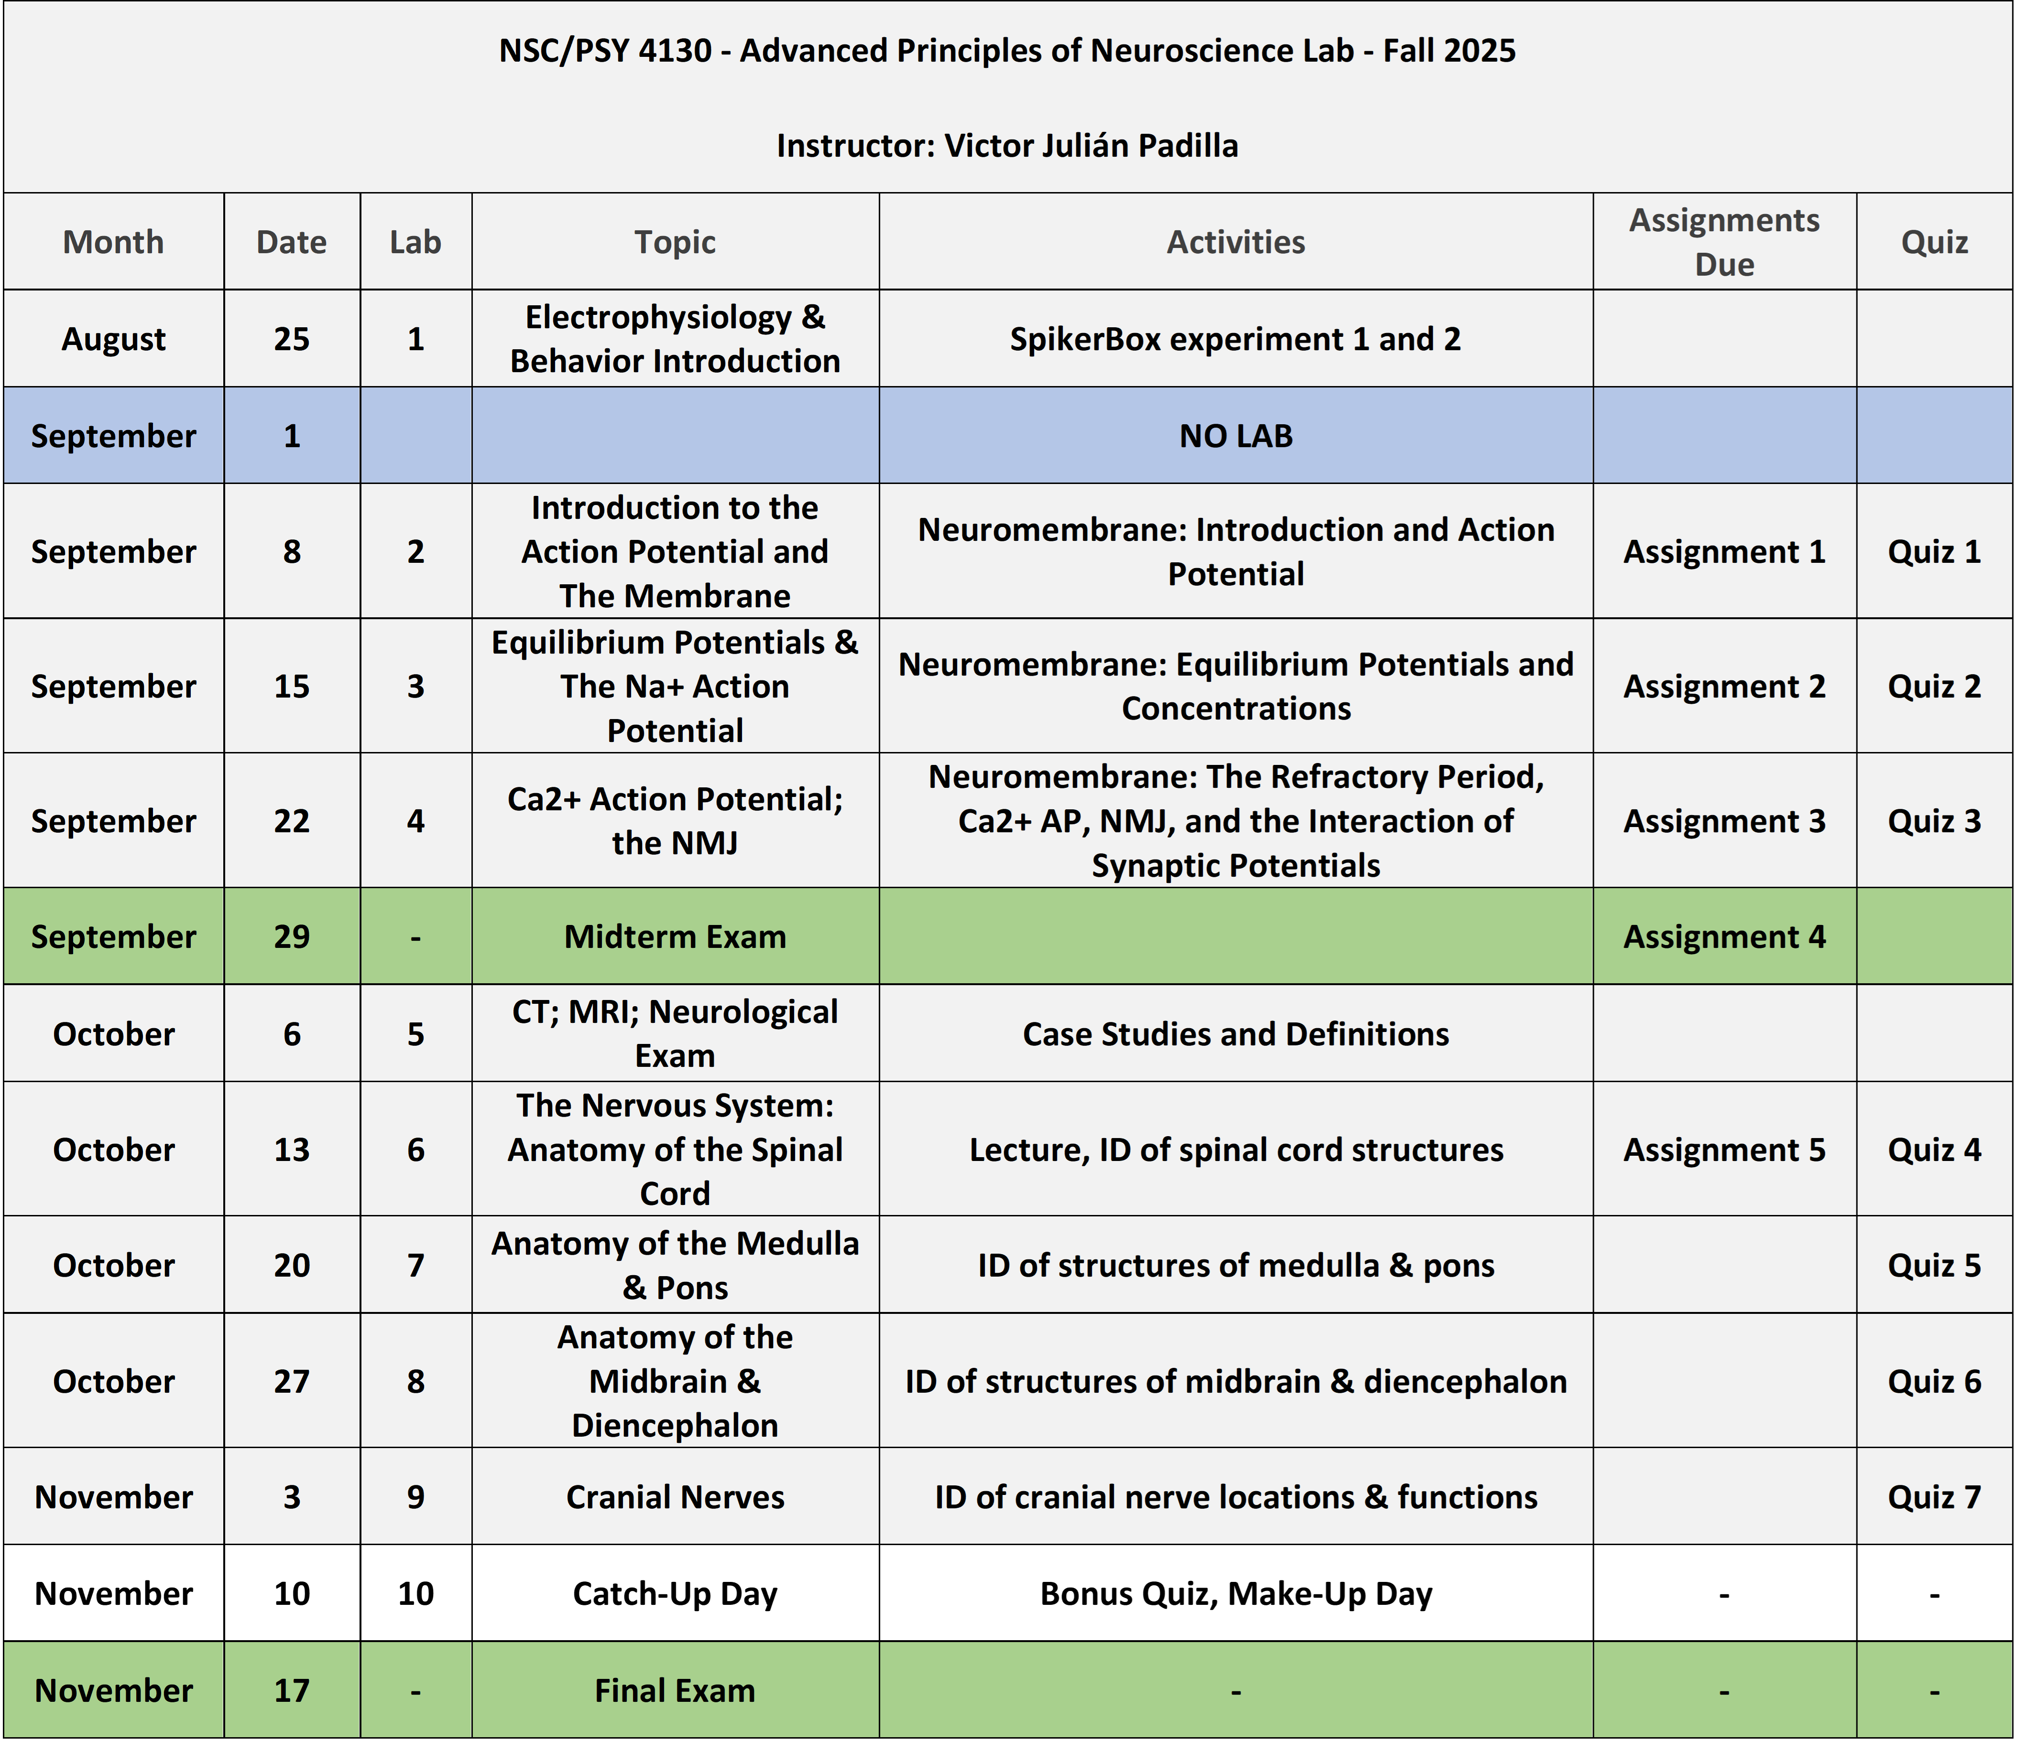

Final Grade Determination
Homework/lab reports 20%
Quizzes 30%
Mid-term Exam 25%
Non-Cumulative Final Exam 25%
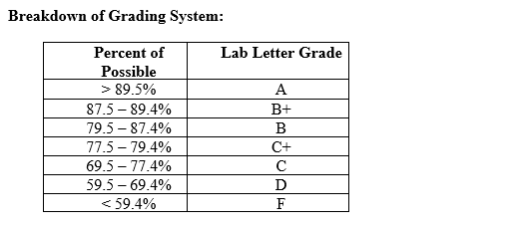

Homework
To ensure your active participation and preparation for class, homework will be assigned throughout the semester. All assignments should be completed individually and should be turned in by midnight on CANVAS the day it is due.

Quizzes
Expect a quiz every week. You will be quizzed on material discussed in the previous lab session, including any information that was assigned for that day’s lab. Additionally, weekly quizzes will serve as markers of your performance and should give you some guidance on the material that you spend more time working on and studying for.

Quizzes will be taken at the time lab is scheduled to start. We will take quizzes through canvas so please bring your laptops to class. If you do not have a laptop, please let me know! You will have 10 minutes to complete the quiz. If you come in late, additional time will not be allotted to complete the quiz. It is therefore in your best interest to arrive on time.

Midterm and Final Examinations
The mid-term exam will include content from the neurophysiology simulation labs from Neuromembrane as well as content covered during the Spiker box experiments. The final exam will emphasize anatomy and function of the brain stem and spinal cord.

Exams will be primarily short-answer and essay format, and the final exam will include identification of key brain structures. Like quizzes, exams will be taken on CANVAS promptly at the time lab is scheduled to start. If you come in late, additional time will not be allotted to complete the exam. It is therefore in your best interest to arrive on time.

Make-up quizzes/exams
Make-up quizzes and exams are allowed for university-approved absences if arranged with the instructor PRIOR to the missed lab session. In the event of illness or emergency, approval must be granted by the instructor BEFORE make-up quizzes and exams will be allowed. Failure to obtain approval will result in a score of “0” for the exam. Contact me immediately to determine the best procedures for making up a missed quiz/exam.

Attendance
You are strongly encouraged to attend every lab as the material discussed will be vital to your performance in the next class and on the exams. Attendance will be taken at the beginning of each lab. In accordance with university policy, all students must attend a minimum of 75% of all scheduled labs. Any student who does not meet this minimal standard will automatically receive a grade of "F" in the course.

Announcements in Canvas
The Announcements section of Canvas will be used to post general messages, reminders, and other pertinent course information that is relevant to all students. In addition to receiving notifications of new announcements upon logging on to Canvas, all students are required to enable real-time (i.e. ASAP) notifications for course Announcements to their respective Baylor University email address. Specific instructions for modifying Canvas notification preferences can be found at https://www.baylor.edu/canvas/doc.php/228284.pdf.

Academic Integrity
Plagiarism or any form of cheating involves a breach of student-teacher trust. This means that any work submitted under your name is expected to be your own, neither composed by anyone else as a whole or in part, nor handed over to another person for complete or partial revision. Be sure to document all ideas that are not your own. Instances of plagiarism or any other act of academic dishonesty will be reported to the Honor Council and may result in failure of the course. Not understanding plagiarism is not an excuse. As a Baylor student, I expect you to be intimately familiar with the Honor Code at: http://www.baylor.edu/honorcode

Academic Success
I believe every student who has been admitted to Baylor can be successful and I want to partner with you to help you thrive academically. Be sure to take advantage of the many resources available for academic success, including coming to see me during my office hours. Familiarize yourself with the culture of success we have at Baylor by stopping by the Paul L. Foster Success Center in Sid Richardson or by going to: http://www.baylor.edu/successcenter/. Even if you don’t need help, you can get involved by tutoring other students in the future or by telling a hall mate how and where to get help.

If I notice that you may be struggling to keep up with the course work for this class, I will submit an Academic Progress Report to the Success Center so that the team of coordinated care professionals can ensure that you get the help you need. Your grade does not reflect who you are and please know that you are capable of achieving your goals for this course. If you feel that you are struggling with the material for this course, don’t hesitate to reach out to me, I am happy to help or direct you towards more resources if needed.

Students Needing Accommodations
Baylor University is committed to the educational success of all students. If you qualify for a learning accommodation, please communicate with me at the beginning of the semester or as soon as you have the requisite documentation from the Office of Access and Learning Accommodations (OALA). The OALA phone number is (254) 710-3605, and the office is located in the Paul L. Foster Success Center - Sid Richardson, East
Wing. Federal law mandates that “No otherwise qualified person with a disability in the United States shall, solely by the reason of disability, be denied the benefits of, be excluded from participation in, or be subjected to discrimination under any program or activity receiving federal financial assistance” (Section 504 of the Rehabilitation Act of 1973). Baylor University complies with all applicable federal and state non-discrimination laws and does not engage in unlawful discrimination on the basis of race, color, national or ethnic origin, sex,
age, or disability in employment or the provision of services.

For Graduate Students
Students enrolled in this lab for graduate credit must also design an empirical study in the field of behavioral neuroscience. The proposed study will conform to the format for NIH grant applications. See instructor for details.

Relevant Websites
http://www-medlib.med.utah.edu/WebPath/HISTHTML/NEURANAT/NEURANCA.html
http://www.brainconnection.com/topics/?main=gal/home
http://www.med.harvard.edu/AANLIB/home.html
http://rad.usuhs.mil/rad/vhproject/vhcoronal.html

First Generation College Students
Baylor University defines a first-generation college student as a student whose parents did not complete a four-year college degree. The First in Line program at Baylor is a support office on campus for first-generation college students to utilize if they have any questions or concerns. Please contact First in Line at firstinline@baylor.edu, call 254-710-6854, or visit www.baylor.edu/firstinline to learn more about the services available.

Military Student Advisory
Veterans and active duty military personnel are welcomed and encouraged to communicate, in advance if possible, any special circumstances (e.g., upcoming deployment, drill requirements, disability accommodations). You are also encouraged to visit the VETS Program Office with any questions at (254) 710-7264.

Office of Equity and Title IX
Civil Rights Policy and Sexual and Interpersonal Misconduct Policy

Baylor University does not discriminate on the basis of sex or gender in any of its education or employment programs and activities, and it does not tolerate discrimination or harassment on the basis of sex or gender. This policy prohibits sexual and gender-based harassment, sexual assault, sexual exploitation, stalking, intimate partner violence, and retaliation (collectively referred to as prohibited conduct). For more information on how to report, or to learn more about our policy and process, please visit www.baylor.edu/titleix. You may also contact the Title IX office directly by phone, (254) 710-8454, or email, TitleIX_Coordinator@baylor.edu.

The Title IX office understands the sensitive nature of these situations and can provide information about available on- and off-campus resources, such as counseling and psychological services, medical treatment, academic support, university housing, and other forms of assistance that may be available. Staff members at the office can also explain your rights and procedural options if you contact the Title IX Office. You will not be required to share your experience. If you or someone you know feels unsafe or may be in imminent danger, please call the Baylor Police Department (254-710-2222) or Waco Police Department (9-1-1) immediately.

